**Summary:**

As part of third increment we concentrated on detecting the gestures that we perform (activity recognition). We have collected accelerometer values X,Y,Z for fast bowling, leg spin bowling and off spin bowling. Then we converted these training files into sequence files. Later we collected combination of gestures for testing and then converted these testing files into sequence file. We used these sequence files in the activity recognition URL and used three gestures training files and testing file to detect the gestures.

**Activity Recognition Scenario and Data collection:**

* **Devices and Sensors:** For this increment we used Sensor Tag to collect the gestures data and we used Samsung S4 device as a mobile client to collect data.

**Design and Implementation of BigDataAnalytics:**

**Motion/activity Models and Machine Learning:**

We have done motion recognition in this incremeent.We have trained three actions fast bowling, off-spin bowling and leg-spin bowling respectively. We made use of HMM model to train our human activity/motion. We have divided data into 3 clusters(fast,off-spin,leg-spin) using k-means algorithm. Initially we collect the training data for 3 human activities fast,off-spin and leg-spin. Then we collect combination train file which involving all 3 motions repeated 3 times each. Now these .txt files are deployed on cloudera.Then we convert these txt files into respective sequence files using web service.Now train these motions based on HMM model.Here we have made use of train web service to train these sequence files. Now follow same procedure to collect test data and convert them into sequence files. Now compare test file sequences with train file sequences to find out the motion.

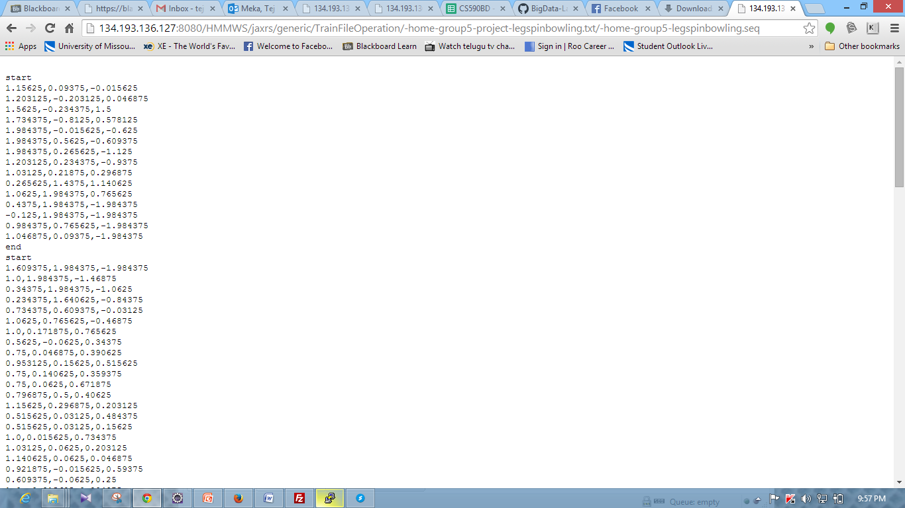

**Screen shot of leg spin bowling gesture data sequence file**

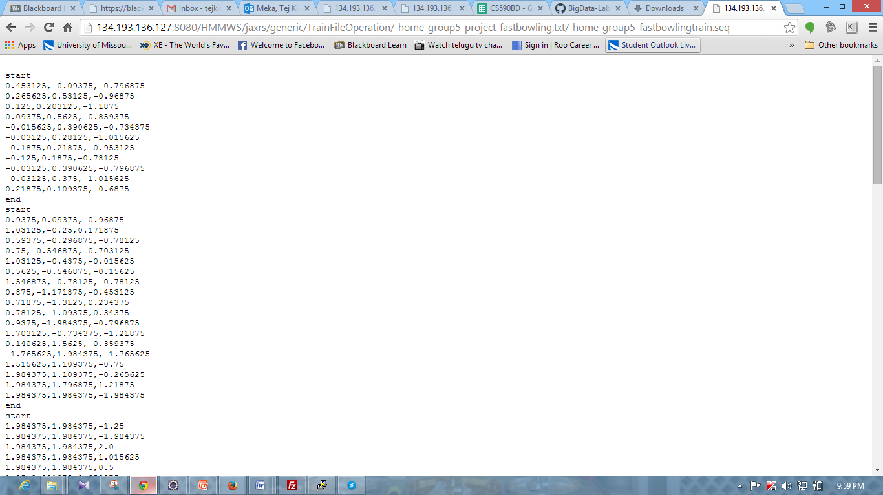

**Screen shot of the fast bowling gesture data sequence file**

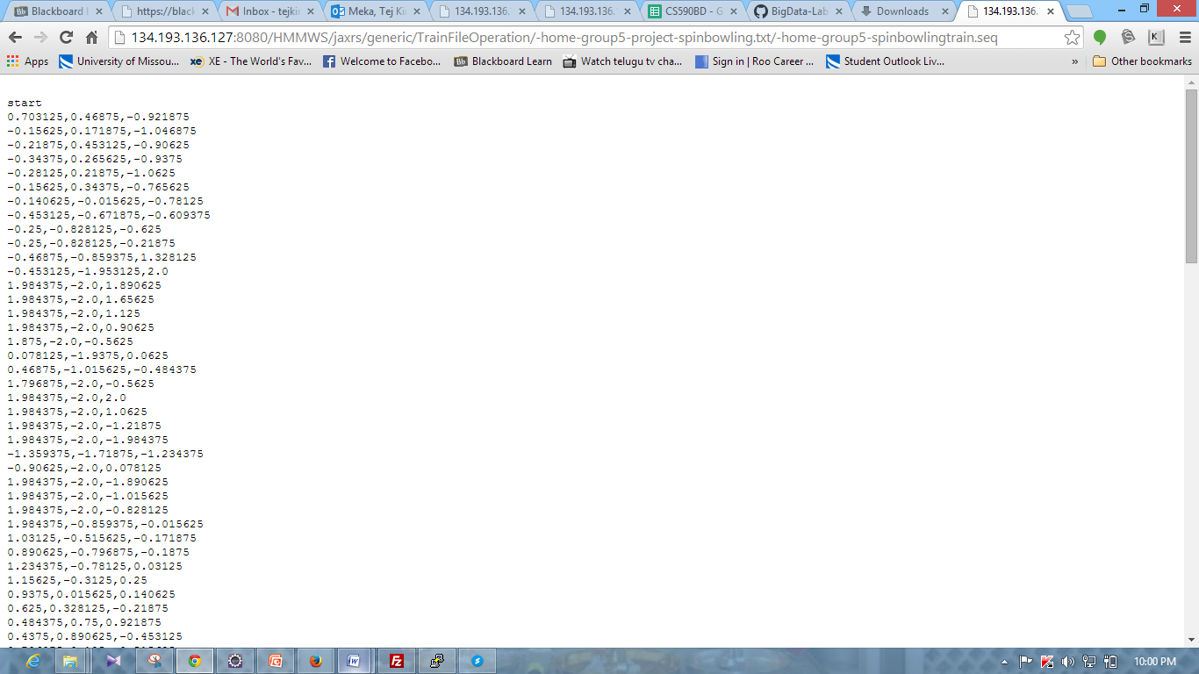

**Screen shot of the off spin bowling gesture data sequence file**

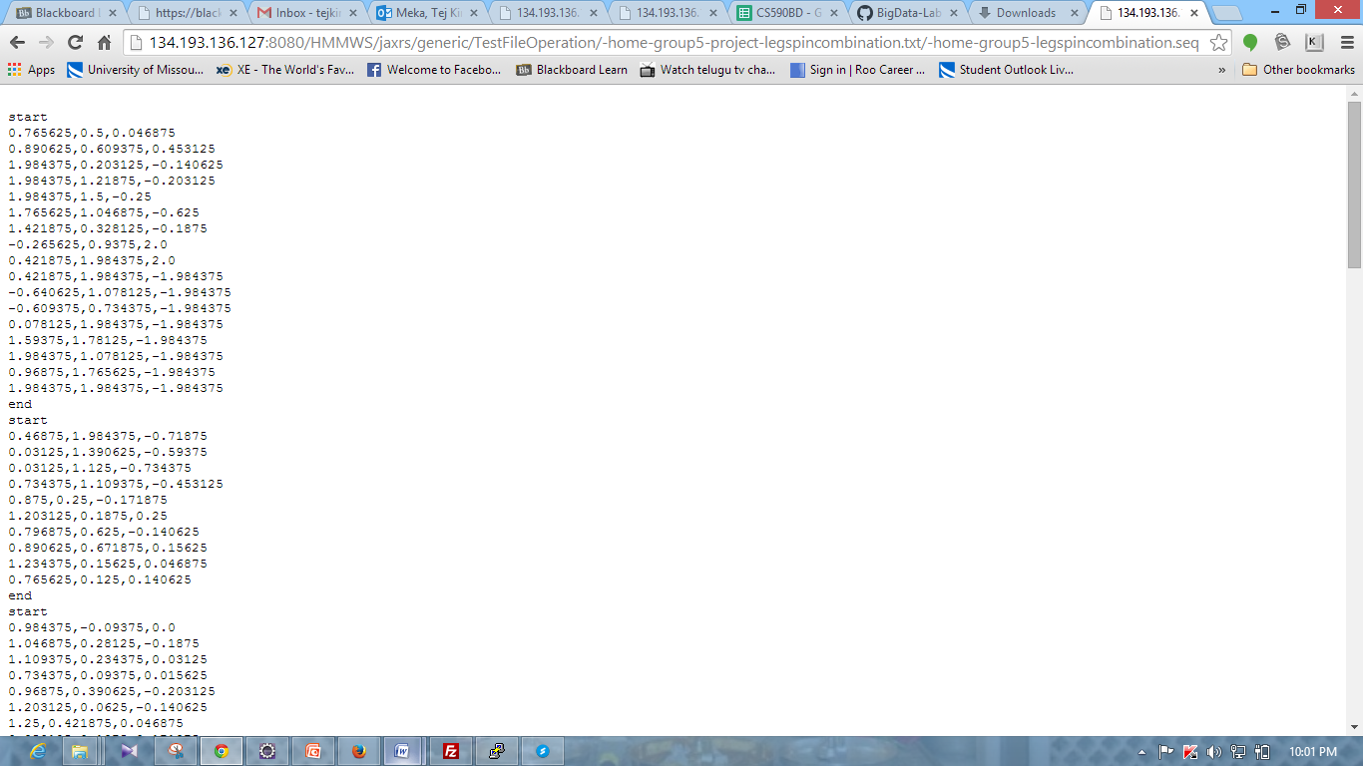

**Screen shot of bowling combination gesture data sequence file**

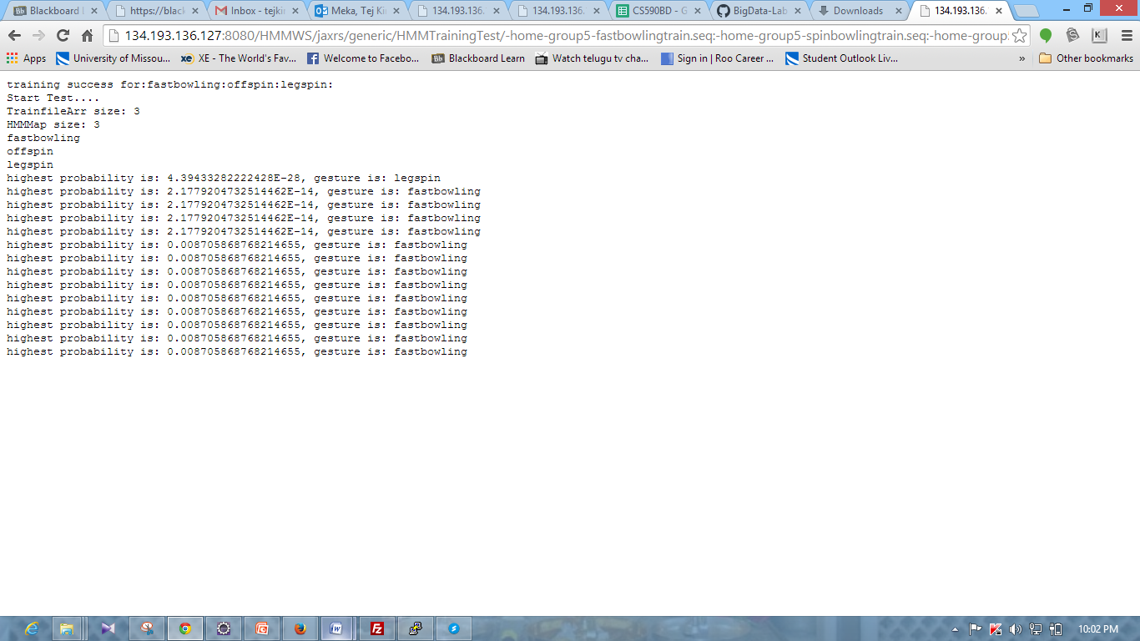

**Screen shot of gesture detection**

**Data Model:**

We use HBase to store, process and analyze motion data. We have created two column families:coordinates,accelerometer to store x,y,z and accelerometer values. We implement CRUD operations on HBase with help of web services.

**Project Management:**

Tasks which are mentioned in our project plan until 3rd increment are completed.

**Fourth Increment:**

Save train file output into a string and compare respective trained motions with actual motion. Detect if the actual bowled action is valid or not. Need to do unit testing. If possible will embed any open source game related to cricket.